Name:____________________
Class:_______
Biography
Mitchell Grafton is a full time ceramic artist making unique sculptural works of art in Panama City, Fl. At age 19 he started working for Odell Pottery while getting an Architecture degree at Louisiana Tech. Bruce Odell was a three time winner of the Pottery Olympics in Wisconsin and taught Mitchell everything he knew about pottery and life for the next 7 years. While at Odell Pottery, Mitchell became the head designer of lamp bases that were produced for Hart and Associates, an interior design manufacturing company. After graduation Mitchell moved to Panama City, FL where he and a business partner started a pottery studio. Mitchell designed, managed and handled the finances for the business for the next 9 years. At its peak, the pottery studio sold wholesale pottery to over 400 art galleries and gift shops around the country and owned a retail art gallery in Seaside, FL. In 2009 Mitchell started his own art-pottery company, Grafton Pottery, in Panama City where he now creates one-of-a-kind works of art.
Photos of some art Created by Mr. Grafton: Face jugs:

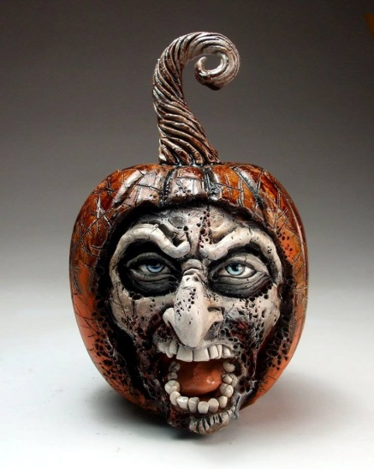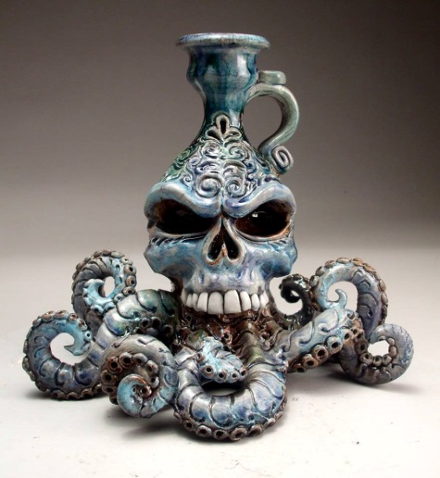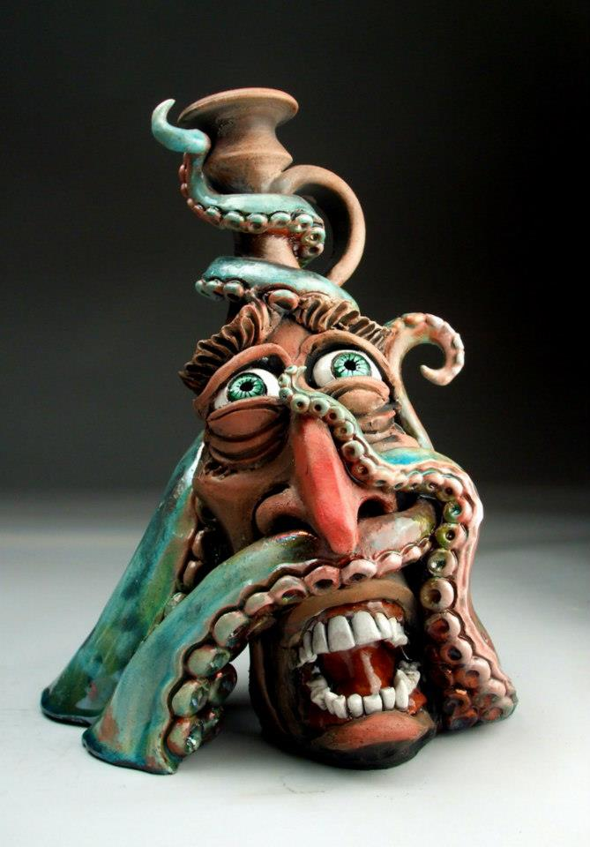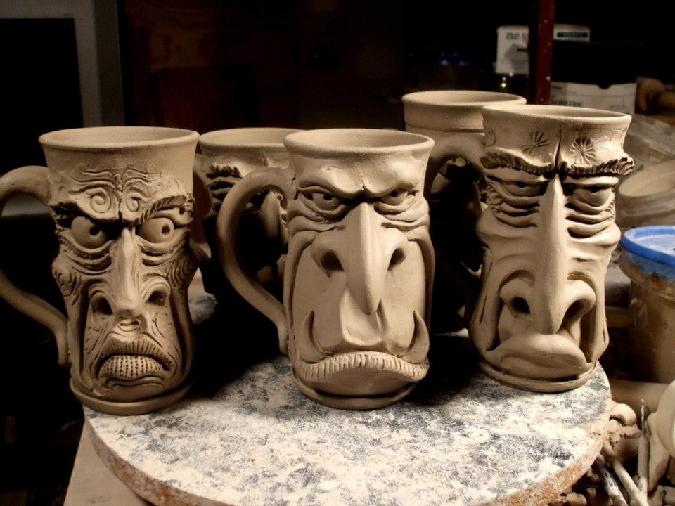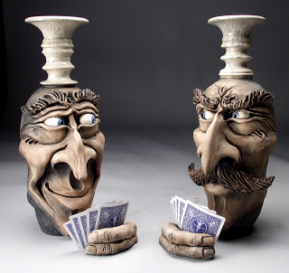

WHAT IS CERAMICS?
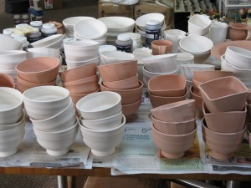
By definition, ceramics is the creation of functional and/or beautiful forms through the manipulation of clay minerals, which are set into rigid form with the application of various heating processes. Most people on the planet are familiar with clay in one form or another, but before beginning to work with clay, it helps to have a basic understanding of its properties, the types of clay available, and basic forming techniques.

CLAY AND CLAY BODIES
Clay is the product of the breakdown of the earth’s rocky surface (primarily feldspar rock) through the actions of wind, water and temperature. These small particles are typically washed down from their formation sites in the mountains and are deposited in lakes, rivers and streams, collecting into deposits known as clay. This process is an ongoing geological system and continues to this day, which is why clay is found in vast quantities all over the planet.
Properties of clay
Temperature: Different clay bodies “mature” at different temperatures. By “mature” we mean fired to the temperature for which they were formulated. In general terms, the higher a clay body is designed to fire, the more it will become water resistant.
Workability: The workability of a clay generally refers to how easy it is to shape without problems. If problems do occur, a workable clay would allow you do fix those problems and continue without crumbling or collapsing.
Color: The color of a clay is affected by the materials used in the blending process. For example, a clay body that has a lot of iron in it will be red like Terra cotta flower pots.
FIRING TYPES
Bisque firing: done between 1657°F and 1945°F
Bisque firing is the typical and very important first step in the ceramic finishing process. During bisque firing both physical and chemical water is driven out of the clay and organic residue burns out.
Volatiles like carbon and sulfur combine with oxygen and escape the clay body.
Fluxes start melting and reacting with the minerals in the clay body to turn that sticky muddy mess you started with into, well, a rock!
This new hardened form will not dissolve when in contact with water nor crumble when handled for glazing.
Glaze Firings: done between 1828°F and 2345°F
Glaze firings are the second and sometimes even the third step in the ceramic finishing process.
They involve the heating and melting of glass forming materials applied to the surface of the clay in order to change them into a layer of glass.
This type of firing is typically a faster process than that of bisque firing due to the fact we are far less concerned about the amounts of water contained in the items being fired, at least if they have been bisque fired!
Unlike in a bisque firing, where it is somewhat acceptable to have items touching one another, in a glaze firing, items should never be closer than one inch from each other, unless it is your intention to glue then together.
The Basics of Glaze:
While applying glaze to a ceramic piece is not absolutely necessary, it can enhance the fired clay piece both on an aesthetic and functional level.
Many clay bodies are not vitreous without being glazed. Glazes, by their nature, are vitreous. When glaze is fired onto a piece it seals the clay making it stain resistant and depending on the glaze, food safe.
After reading complete the questions.
- Where can clay be found in nature?
_______________________________________________________________________________________________________________________________________________________________________.
- What does the workability of clay refer to?
_______________________________________________________________________________________________________________________________________________________________________.
- A clay body that has a lot of iron will most likely be what color? _________________
- Circle True or False. A Bisque firing is hotter than a glaze firing.
- What will happen if projects are touching during a glaze firing?
_______________________________________________________________________________________________________________________________________________________________________.

Before creating a sculpture, artists will create a sketch to show what they will be trying to achieve with their work. This is an example of a sketch and the finial project of one of Mitchell Grafton’s art works.
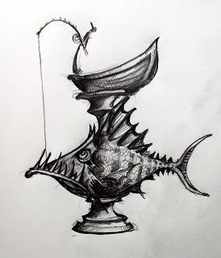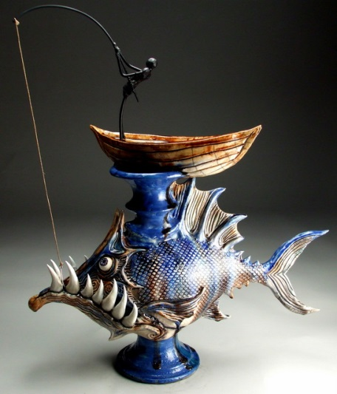
Your sketch does not have to look as extravagant as this, but create a sketch of what your mug might look like. Think about the funky, funny, misplaced features your mug might have. Think about the handle and how that will be incorporated. Draw your sketch in the box below. You may color with color pencils to help show off your mugs beautiful features. You may also label parts if to get others to understand your vision as well.

