Requirements:
- Your project is five strips of paper
- These can be arranged in any order
- You will draw a cohesive piece that expands throughout all five strips. (just a normal drawing pretend it is one piece of paper)
- Each strip will emphasize a different element of art
- You must include 5 elements
- Once complete write a few sentences on how your piece also incorporates to principles of design.
Learning objectives:
Students can create a cohesive piece of art that uses at least 5 elements of art.
Student can identify and apply 5 elements of art in their work.
Students can apply two principles of art, and explain how they accomplished them in their writing.
Standards:
A.12.2 Know advanced vocabulary related to their study of art.
C.12.1 Use the elements and principles of design in sophisticated ways.
L.12.1 Use their knowledge, intuition, and experiences to develop ideas for artwork.
10-9 8-7 6-5 4-0 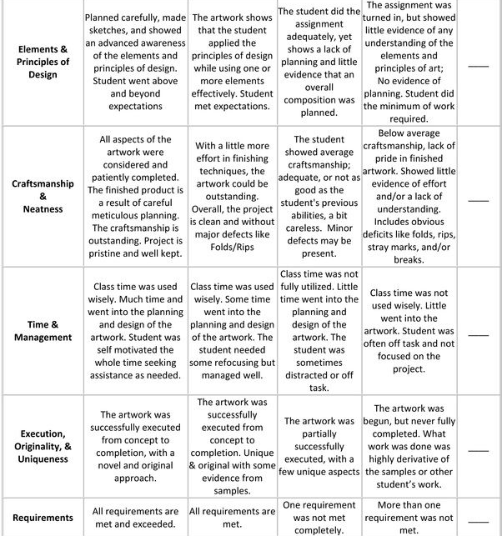
Total possible points = 50
Points earned:
Extra comments:

