Have you ever wondered what meanings are hidden behind 17th century still-life paintings? When these artworks were painted, their audience could understand what messages were conveyed at the first glance. However, for a modern audience, these still-life scenes can look like just random supermarket objects.

A Still Life is a work of art depicting mostly inanimate subject matter –flowers, food, dead animals, shells or man-made objects such as drinking glasses, books, vases, jewelry, musical instruments and so on-, gathered on a table or in a niche, sometimes with “Vanitas” elements that reminded the emptiness of material pursuits and futility of earthly ambitions.

The rich middle class had disposable income and collecting paintings –especially still life- was a good way to establish a high position in society, showcasing their good taste and wealth.

As a subject matter, still-life painting is popular since antiquity. Ancient Greeks and Romans often decorated their homes with depictions of fruit baskets, game or other still-life scenes. Later in the course of art history, still-life painting emerged more or less simultaneously in Italy, northern Europe and Spain in the sixteenth century, while the Dutch still life painting became the most lavish, most sought after type.

These simple paintings of flowers, food and such gathered together had complex meanings and various messages for the viewers. Sometimes the subject matter could be the sole reason why a certain person bought a certain painting. The Bourgeoisie’s interest in buying art opened up a new marketplace for art, which was the beginning of the first art economy in the modern sense. The rich middle class had disposable income and collecting paintings –especially still life- was a good way to establish a high position in society as a connoisseur, showcasing their good taste and showing off their wealth. This is the exact reason that still life paintings often feature objects of trade, probably because it convinced a merchant to buy a significant painting with objects of his trade: for example, a grape merchant who imports grapes from Spain would be delighted to buy a still life with grapes.

The conservative values of the era affected the messages conveyed by the still life paintings heavily. The central “memento mori” theme (literally “remember that you have to die”) in Vanitas Still Life reminded the viewer not to get too lost in enjoying oneself with wealth, gluttony and music but rather to focus more on the spiritual aspects of life. Let’s take a look at the meanings hidden in these simple objects.

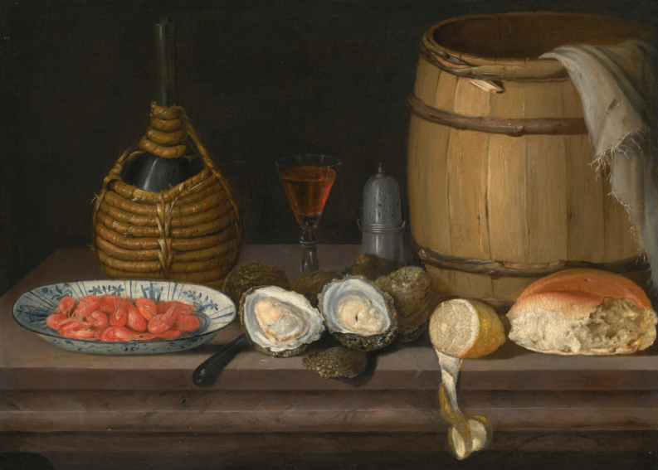

Dutch or English School, early 18th century. Still Life of Shrimps in a Porcelain Dish, Sold for GBP 6,250 on 7 July 2016 at Sotheby’s.

Oyster: Oysters have been a sort of gourmet food since antiquity. Ancient Greeks and Romans saw oyster as a delicacy, and a medical remedy.

Bread: Everyday life, humility, Catholic host (the body of Christ)

Peeled lemon, as an expensive fruit for that time, also stands for wealth. Expensive delicacies such as shellfish and lemons were associated with a privileged and gentle lifestyle, which the owner already enjoyed or wanted to be identified with. It is possible they don’t carry a significant allegorical purpose but just stand as general reminders of the transient nature of luxury, the virtue of temperance, or warn against the perils of gluttony.

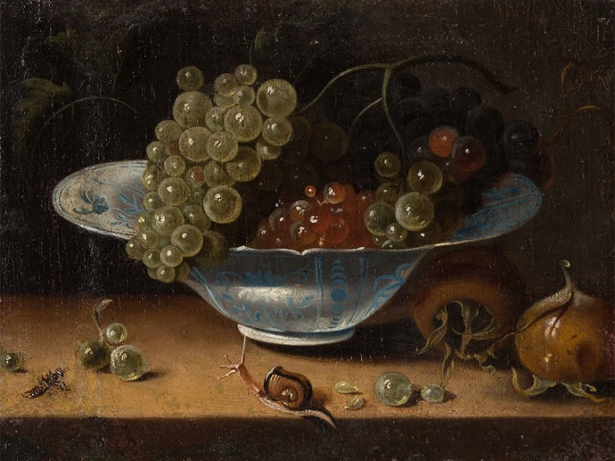

Jacob Marrel (1614-1681), Still Life With Grapes, c. 1670/80 Price est.: € 13,000 Auctionata

Jacob Marrel was a well-known follower of the Dutch School of the 17th century, whose works occasionally fetch up to six-figure hammer prices at international auctions. Let’s take a look at the symbolism in the painting:

Snail: From Matisse to the Old Masters, snails are commonly depicted in art and carry rich symbolism. Since early Renaissance, snails were considered an image of the Virgin Birth and the dogma of the Immaculate Conception of Mary, possibly because people could not imagine how snails would reproduce. Some resources site snails also as symbols for humility and everyday life.

Bee: A bee in a still life painting signifies the brittleness of life and how helpless we are against the course of destiny, also encourages industriousness. This is different than other insects depicted in still life painting, devouring the fruit or dead animals, which signifies death and “memento mori”.

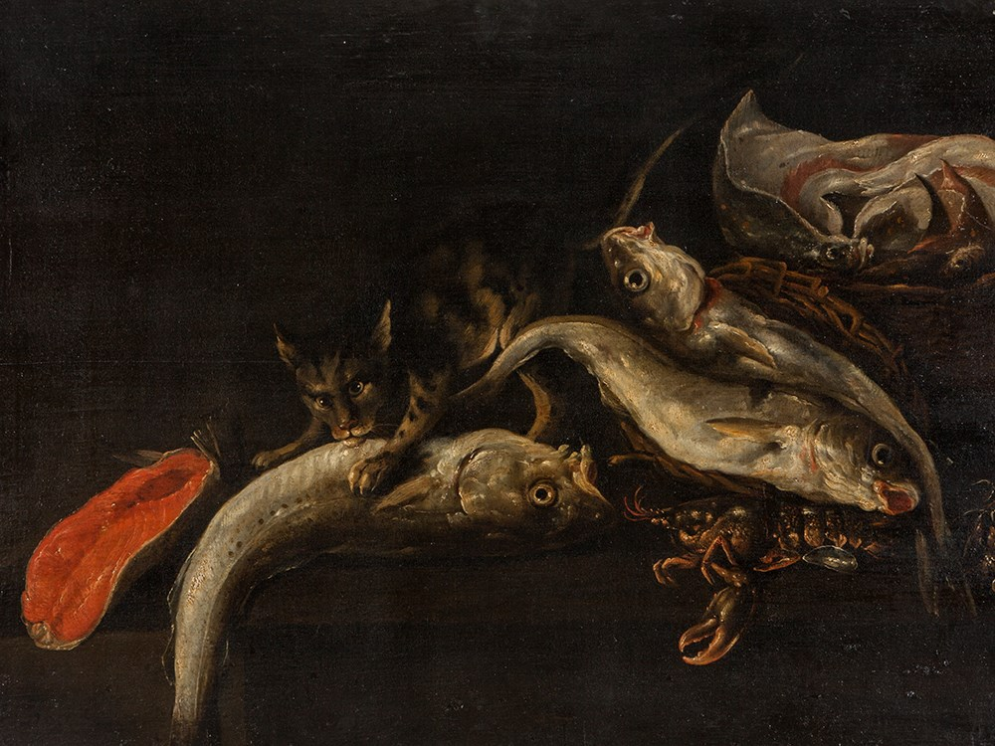

Isaac van Duynen (1628-1680), ‘Fish Still Life’, 17th Century Price est.: € 6,000 Auctionata

The Dutch still life painter Isaac van Duynen(1628 – ca 1680) was active in the Golden Age and is mostly renowned for his outstanding fish still lifes.

The fish are painted in bright colors and clearly stand out from the dark. Amongst them, one can recognize the shining shell of a lobster. In the center of the painting appears a cat, sinking its teeth into a fish.

Fish and cat: Death as a general theme appears in this painting with the dead fish being eaten by a cat. Fish was a symbol for Christ and cats were considered images of indiscretion or unteachable beings that aid evil. So possibly the artist is trying to warn against a danger to faith, maybe by gluttony hidden in the shining shell of the lobster below the fish.

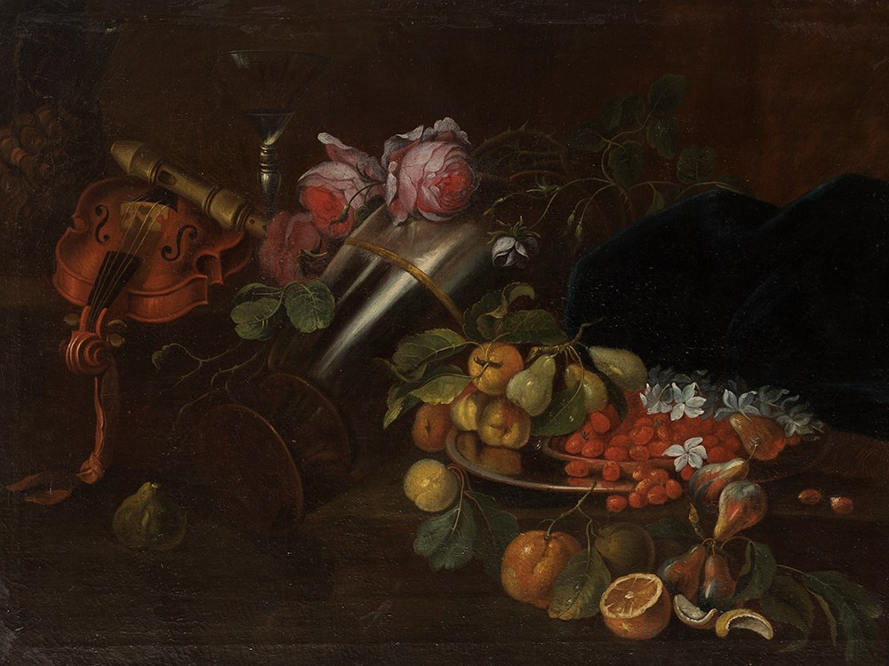

Jean-B. Monnoyer (1636-1699) Follower, Still Life, 18th C. French painter. Price est.: € 3,600 Auctionata

Another highlight from the Classic Works of Art – Paintings of the 16th – 20th Century at Auctionata is this Still Life by a follower of the French painter Jean-B. Monnoyer, famous with his still life paintings. This piece is also full of hidden vanitas messages. Vanitas is a category of symbolic works of art, especially associated with 16th and 17th century still life. The Latin noun vānĭtas literally means “emptiness” and the central theme in these paintings is the Christian view of earthly life and the worthlessness of all wealth and ambitions. This painting is full of those messages.

Rose: Roses with thorns symbolize Virgin Mary’s suffering.

Violin: The violin, with its easily snapped strings, symbolizes the broken threads of time and indicates the futility of earthly existence.

Glass: The almost empty glass signifies brittleness of life but also since glass was an expensive object; it stood for a life of luxury.

Gold or silver objects: Expensive luxury items depicted wealth and power in still life paintings, however, when they are tipped over, as in this painting, the message encourages moderation and reminds the transience of earthly riches.

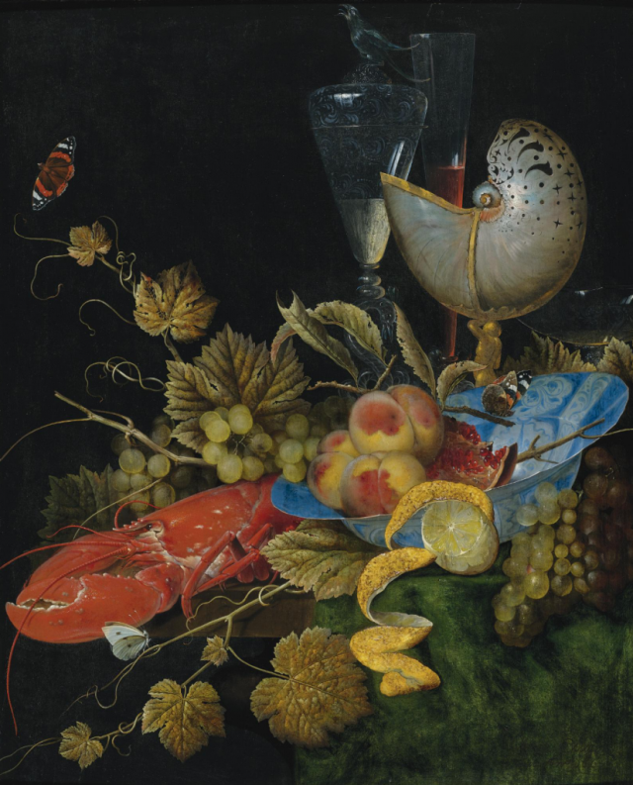

Ottmar Elliger the Elder, Still Life with Lobster, Fruit and a Nautilus Shell, sold for 182,500 in 2009 at Sotheby’s

Here, for example, the Red Admiral butterfly floats beside the informal still-life arrangement, thus expanding the picture plane and emphasizing the seeming randomness and spontaneity of an arranged scene, as if these objects came together on their own.

Nautilus Shell: The nautilus shell serves as a replacement to the more omnipresent depiction of the human skull, acting as a reminder of the inevitability of death, or memento mori, while keeping the grim image of a skull out of the picture.

Butterfly: Butterfly represents the soul, transformation and resurrection, and the hope of the caterpillar to emerge out of a cocoon as a beautiful butterfly.

Pomegranate: Fertility, desire, abundance, but also resurrection and immortality, inspired from the mythological story of Persephone and Hades.

Peaches: Peaches stand as an image of trade from warmer countries but also, the artists of Renaissance symbolically used peach to represent heart, while a ripe peach was also a symbol to imply a ripe state of good health.

Vine Leaves and grapes: The vine leaves enclosing the food could be representing Christian values and Jesus, as a reminder of the wine Jesus offered to his apostles at the Last Supper. They could also be symbolizing earthly pleasures, through the God of Wine, Bacchus.

Lobster: All pieces of meat, ham, game and shellfish symbolize wealth, gluttony and temptation, while drawing attention yet again to the transience of wealth.

