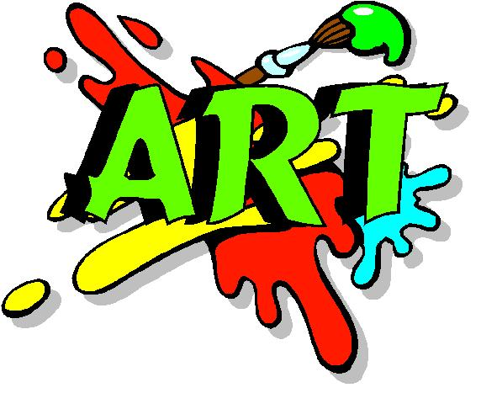
Welcome to 6th Grade Art!!!
Dear Parents and Students:
Welcome to another exciting trimester at Lomira! My name is Ms. Koepp, I am the middle and high school art teacher. Welcome to 6th grader art! I hope you all enjoy yourselves here in art and that you all leave with knowledge and memories that help you advance into the next level of art.
Students will be experiencing a variety of assignments. They include:
- Drawing
- Painting
- Learning Color Theory
- Clay
- Learning to talk and write about art
- Art History
- Learning the Elements of Art
- Other projects if time allows
Students will be graded on:
- Quality of work
- Effort, and Energy put into work
- Creativity and Originality
- Cleaning up materials and their work station
Expectations in the art room are as follows:
- Read and follow the student/ parent handbook
- Respect for the teacher, classmates, and art work
- Using appropriate language, keeping hands to themselves, not speaking when others are speaking
- Respect materials, keeping them clean and put away correctly
- Respect the safety of others by not throwing any objects and using materials how they are instructed
- Raise hand to speak
- Speak in a low, considerate voice when conversing with classmates
- Head phones, cell phones, IPods, should not be out unless otherwise instructed (will be taken away and held to end of the class period if student is using these materials without permission)

Late Work:
- Late work will be accepted.
- Note: Late work does not mean skipping an assignment completely. If assignments are not turned in by the finial due date before grades are due it will result in a 0 in the grade book.
- Absent: If you are sick or miss a lot of class time we will come up with a different due date. It will not be considered late.

Extra suggested material: Folder with a couple of pieces of loose leaf paper- To help you keep track of assignments and note when we take them.

Please read and discuss this course material with your parents/ guardians and return it to class after you have both signed in the appropriate place below.
I am looking forward to this year and I can’t wait to see all the wonderful art you create!
If you need to contact me for any reasons, questions, or concerns, please feel free to send me an email at kkoepp@lomira.k12.wi.us .

Thank you for your time!
Sincerely,
Kayla Koepp

Please cut on the line and keep top half for yourselves. Turn in only signed part.
I, _________________________________, have read the class expectations, grading procedures, and assignments information.
___________________________________________________
Student
I have read the expectations, grading procedures, and assignments information and I feel this will be an enjoyable experience for my child.
____________________________________________________
Parent

